Abstract : This paper proposes a new model for studying the new product development process in an artificial environment

Connectionist models - Also known as Parallel Distributed Processing (PDP) models, are a class of computational models often used to model aspects of human perception, cognition, & behaviour, the learning processes underlying such behaviour, and the storage and retrieval of information from memory.

A learning curve is a correlation between a learner's performance on a task and the number of attempts or time required to complete the task; this can be represented as a direct proportion on a graph. It proposes that a learner’s efficiency in a task improves over time the more the learner performs the task.

Impact of incentive schemes (local, hybrid, and global) on the new product development process for different types of organizations.

Incentive schemes - an arrangement under which a company makes extra payments to employees to reward good performance.

Sequential organizational structures are compared to two different types of team-based organizations, incorporating methods of quality function deployment such as the house of quality.

7-Types of Organizational Structure Types

1) Hierarchical Structure

2) Matrix Structure

3) Horizontal/Flat Structure

4) Network Structure

5) Divisional Structure

6) Line Organizational Structure

7) Team-based Organizational Structure

Quality Function Deployment (QFD) is a structured approach to defining customer needs or requirements and translating them into specific plans to produce products to meet those needs. The “voice of the customer” is the term to describe these stated and unstated customer needs or requirements.

The house of quality process is a component of QFD. The QFD method helps you assure quality when you develop products and deliver services. QFD uses various matrices for this purpose. The first and often most important matrix in QFD is called the house of quality because it’s shaped like a house with a roof and body. In this matrix, you start by separating customer needs from technical requirements &evaluating the 2 factors independently of each other. You then correlate 2 types of requirements & start planning for implementation.

A key finding of this analysis is that the firms’ organizational structure and agents’ incentive system significantly interact.

New product decisions have significant strategic implications that determine the future of a business and involve several functional areas within an organization. Successful products must satisfy a range of constraints.

Resource-based view is well-suited to explain firm‘s success in new product development. The resource-based view (RBV) is a model that sees resources as key to superior firm performance. If a resource exhibits VRIO attributes, the resource enables the firm to gain and sustain competitive advantage.

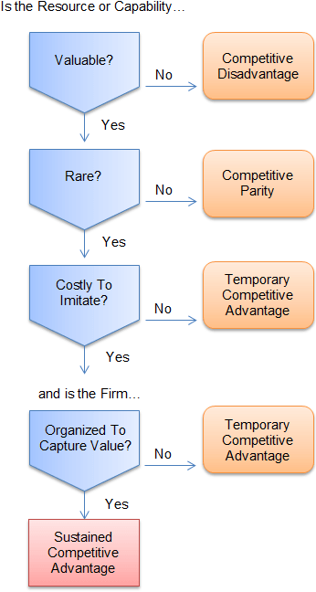

The Environment :

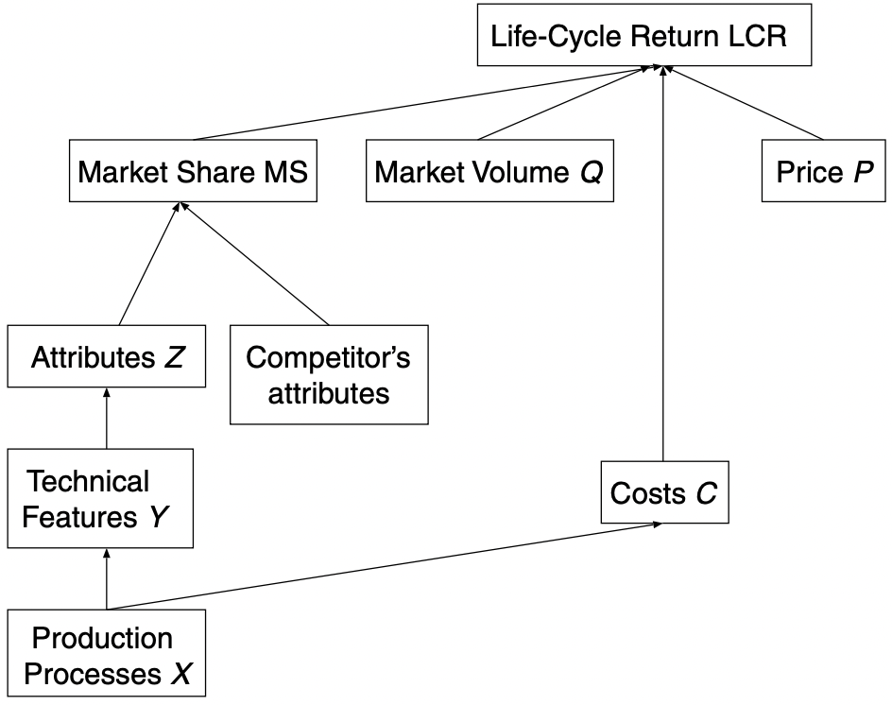

1. Production processes X (at the bottom of Figure 1) determine costs (C) and the technical features Y of a product.
2. Customers only view the attributes Z of the product, whose value is influenced by the technical features Y.
3. Market share (MS) of the product depends on both the attributes of the product, and those of the competitors.

What is Market Share ? - It is a measure of the consumers' preference for a product over other similar products. Higher market share means greater sales, lesser effort to sell more & a strong barrier to entry for other competitors. Higher market share also means that if the market expands, the leader gains more than the others.

1. Return of a product in a period is determined by its price, market share, costs, and the market volume of that period. Finally, the life-cycle return (at the top) is calculated as the sum of returns over the whole life cycle.
2. The production function X → Y is captured by the following relationship: Y = 1/(1 + e^−AX)
3. A is a matrix of the production function describing fundamental technical relationships. A is the same for all organizations under consideration. The matrix A is used in our simulation to control the inter-feature dependency of technical features. Thus, relationships such as the top speed of a car and its fuel consumption can be modelled.
4. As compared to classical microeconomic production functions such as Cobb-Douglas, our production function has the advantage that negative correlations between technical features Y are allowed

Cobb-Douglas : It is a particular functional form of production function, used to represent the technological relationship between the amounts of two or more inputs and the amount of output that can be produced by those inputs.

1. Costs of production are a linear function of X, with c as the vector of costs: C = (c^T).X. The vector c is constant in time and the same for all organizations with ci as the cost of a single production process i.
2. To map technical features Y to product attributes Z as perceived by the customer, a nonlinear function, implemented as a two layer neural network with sigmoid transfer function, is used.
3. In this environment, firms simultaneously develop products and compete on the same market. Thus, attractiveness of a product is perceived relative to the attractiveness of all products on the market. The attractiveness of a product is a function of the product position relative to an ideal point, Z∗. We model the distance of the product offering to the ideal point as a weighted Euclidean distance.
4. Life-cycle (LC) effects are modelled by the classical Bass model - It consists of simple differential equation that describes the process of how new products get adopted in a population. With only 3 parameters (rate of innovators (p), rate of imitators (q), market potential (Q)), sales quantity of each period is determined. The life-cycle return (LCR) for each firm can then be calculated as the sum of profits over all periods.

Agent Modelling with Neural Networks : In agent-based modelling (ABM), a system is modelled as a collection of autonomous decision-making entities called agents. Each agent individually assesses its situation and makes decisions on the basis of a set of rules.

A major goal of agent-based simulations is to demonstrate the behaviour of complex systems guided by boundedly rational agents.

The aspects which we consider in this paper are :

1. Recognizing that knowledge & learning is limited for humans, and modelling this accordingly, we achieve a means of describing bounded rationality.

2. One can assume that each agent still behaves rationally, meaning that it attempts to optimize a given utility function and always acts accordingly, but that the knowledge about this utility function is limited (bounded knowledge). 3. One can assume that the agent acts fully rationally, but time & other resources are limited,& agent thus must resort to a suboptimal solution (bounded computational ability)

2 kinds of agents were used :

1. Marketing agent - It learns the relationship between technical product features and customer perceptions as well as the relationship between perceptions and attractiveness of the product perceptions.
2. Production agent - It builds models on the relationships between production processes and technical product features. It also has to learn the relationship between production processes and costs.

We chose the most simple form—a feed-forward neural network designed to learn the desired behaviour of an agent as an unknown nonlinear function.

Using neural networks, only long-term learning & knowledge is being modelled. This shouldn’t be confused with agent’s ability to apply rules, text- book knowledge and strategies. Therefore, the neural network in our overall model reflects only the long-term expertise of an agent, given past experience, to achieve a solution in its domain by approximating the unknown function.

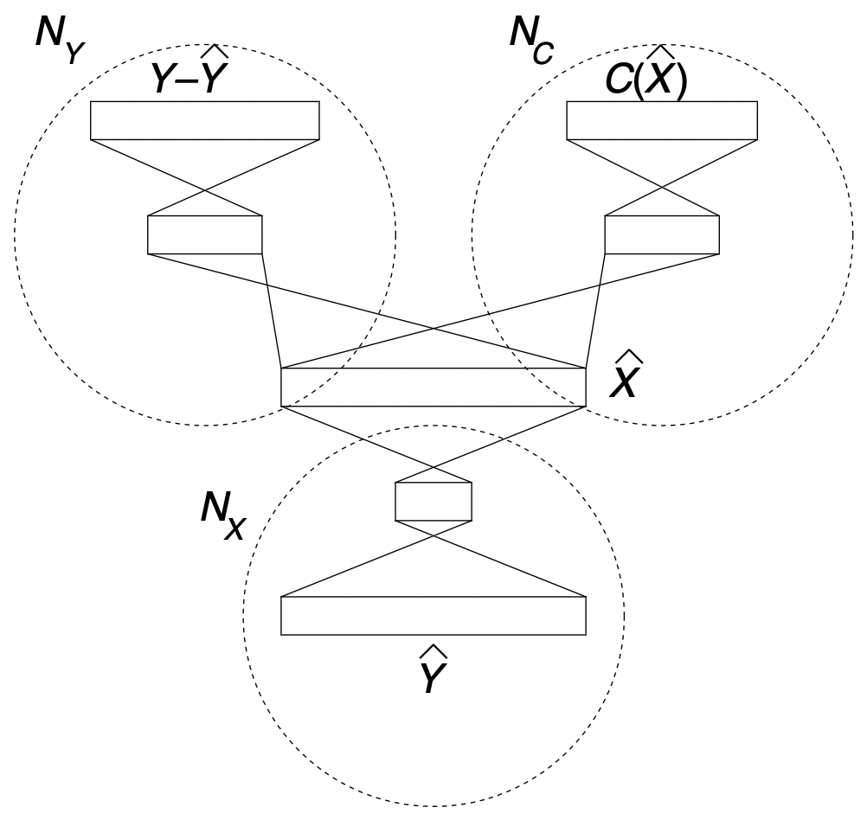

required technical features ^Y

resulting technical features Y

production processes ^X

multilayer perceptron NX

The basic task of the production agent is to learn the nonlinear relationship between required technical features and production processes. This is done through a multilayer perceptron NX with one hidden layer

Ny - suggest an appropriate set of production processes

Nc - to minimize the costs of the product to be suggested

Nx – relationship between production process and technical features

Networks NY & NC constitute agent’s knowledge about how a given set of production processes lead to a final product & what its costs would be. These networks represent a kind of general knowledge about production, whereas NX represents expertise to turn requests into an optimal product. All multilayer perceptron’s consist of hidden units & output units with sigmoid activation functions.

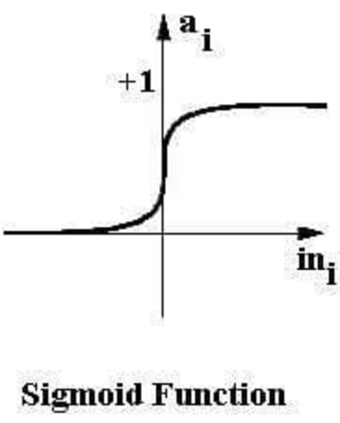

Sigmoid is the S-curve and outputs a value between 0 and 1.

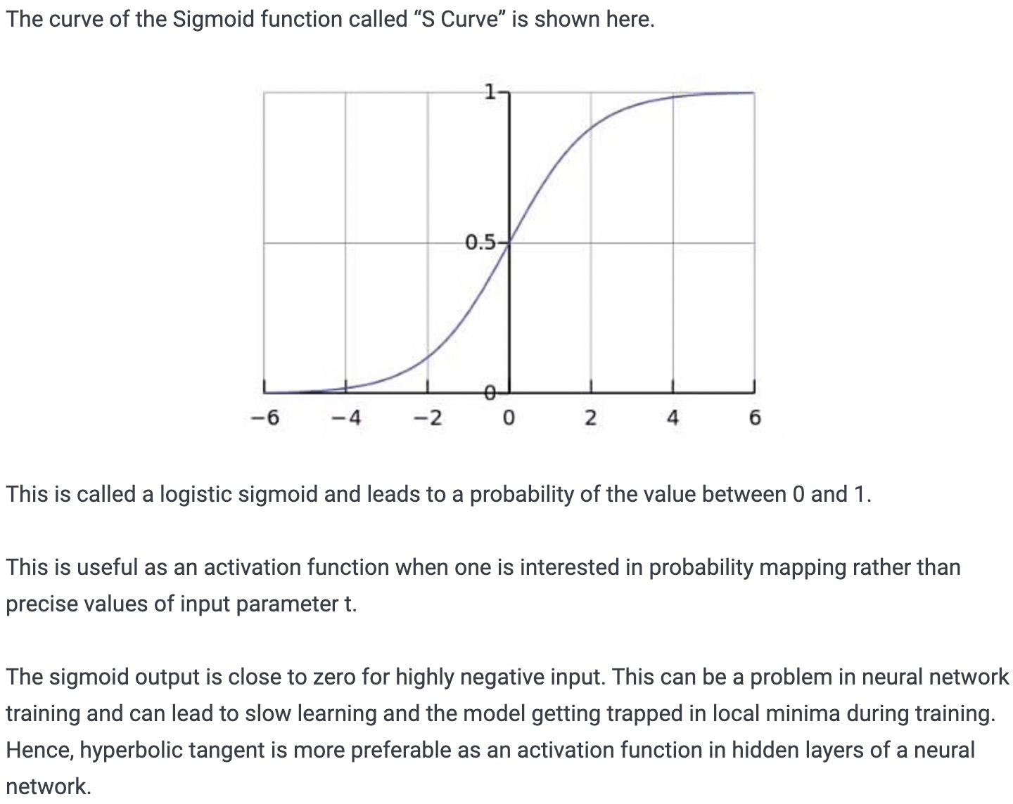

While most connectionist models use standard backpropagation as learning algorithm, we chose SCG for reasons of better performance.

SCG : scaled version of the conjugate gradient optimization (SCG) algorithm. It is a supervised learning algorithm for feedforward neural networks, and is a member of the class of conjugate gradient methods. SCG has been shown to be considerably faster than standard backpropagation and then other CGMs

The marketing agent is modelled in a fashion similar to the production agent. It consists of two multilayer perceptron’s designed to learn the functions Z = G􏰇Y􏰈 between product features Y and product attributes Z, as well as between product attributes and attractiveness f 􏰇Z􏰈. Function Y = F 􏰇Z􏰈 has to be learned, where F is the inverse of function G. The properties of the networks and of learning are analogous to the production agent.